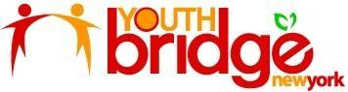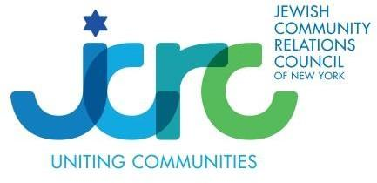

Fellowship Application Preview Questions

Short Answer Questions

What does the word "diversity" mean to you? How do you see diversity in your school or community?
What is your vision of leadership? Who would you consider a leader? Please cite an example.
How have you acted as a leader before? What was the issue (if any), the goal, and the end result? (Among your friends, at home, etc. Be creative! It can be a small event where you stepped out of your comfort zone.)
Who are the people that have the most impact in your life? Why? (Can be someone dead or alive, close to you, or even someone “famous” like a social media influencer)
What skills would you like to develop as a YouthBridge-NY fellow?
What unique perspective will you bring to the fellowship?

Short Essay

Directions: Please read the article below and answer the questions following the article.

DoSomething and YVote are spearheading the Civic Participation Ecosystem to deepen New York young people’s knowledge of the electoral system and its impact on their lives and extend their civic participation between election cycles. We aim to bring together leaders of key civic nonprofits, researchers, evaluators, and funders as part of the Coalition and Steering Committee to map out the ecosystem, along with a civic hub to make opportunities known and navigable by young people, families, and schools. This civic hub would activate a broad range of young people in New York City, emphasizing marginalized communities, by helping them, their families, and their teachers identify and engage with high-quality civic opportunities that align with their interests. This hub would certify civic learning for young people to ensure that they receive recognition for what they've achieved in a way that will be validated by city and state stakeholders, leading to lifelong civic learning and participation. The heart of this work is instilling New York’s young people with strong civic identity, agency, and efficacy and equipping them to be informed, engaged civic actors. This group will also consider ways public and private funding can strengthen civic opportunities for young New Yorkers, with an emphasis on underserved communities. By the end of year two, the network will release a report on our process, findings, and recommendations.

Who are the people that DoSomething and YVote hope will comprise the Civic Participation Ecosystem? What issue does DoSomething and YVote seek to address in New York? What opportunities do DoSomething and YVote offer teens? What is the anticipated long term impact listed in this prompt? What are other ways that the New York community might benefit from a Civic Participation Ecoystem?

Letter of Recommendation
We ask that you provide the name and contact information of an adult (teacher, counselor, advisor, etc.) who can offer a reference for you.

